Discovering Classes

Discovering Classes 1
Translated into Code 2
Initial class diagram 5
Singles and Plurals 6
Authentication Example 6
How do we find Associations? 8
Multiplicity 10
Composition 11
Aggregation 12
Collection Classes 13
What is the Difference between a Class and an Entity? 15
Classes do not persist 16
Classes have Functionality Entities Don’t 16
“But really – aren’t they basically the same thing?” 18
Representing an Order 19

Discovering Classes
The class diagram allows us to plan out the code that will drive our system without having to worry about the actual code.
Below is the class diagram for an address book application...
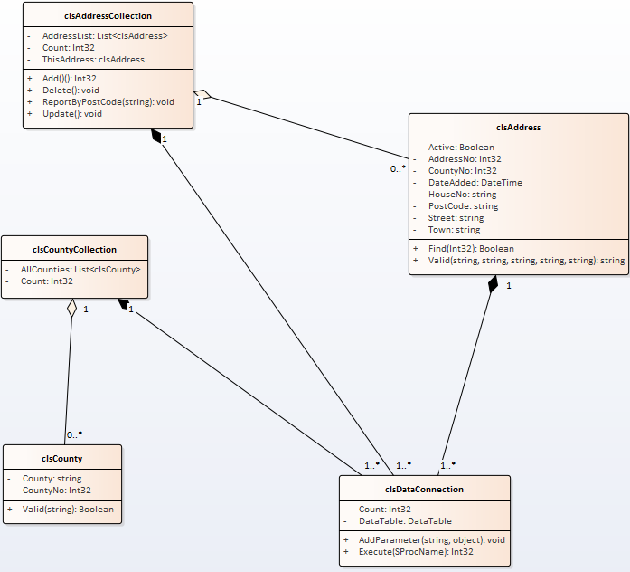
When the system is completed each of the rectangles will be implemented as a class in the middle layer of the system.
For example clsAddress on the diagram looks like this...
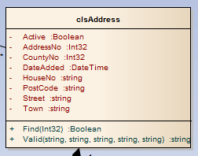
Notice the three sections to the class.
At the top we have the name of the class...
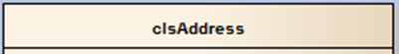
The next section describes the attributes of the class...
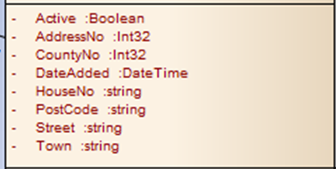
The last section describes the operations of the class...
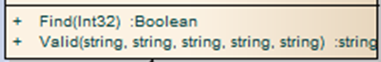
Just to clear up a possible point of confusion...
Systems analysts tend to talk in terms of attributes and operations when creating class diagrams.
Programmers tend to talk in terms of properties and methods.
In reality they often amount to the same thing.

Translated into Code
In Visual Studio this class on the diagram will translate into a class in our middle layer...
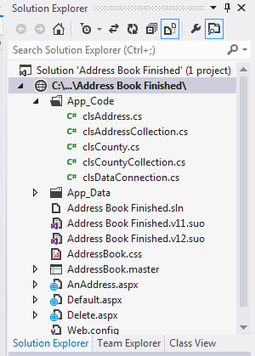
With code for each attribute implemented as properties...
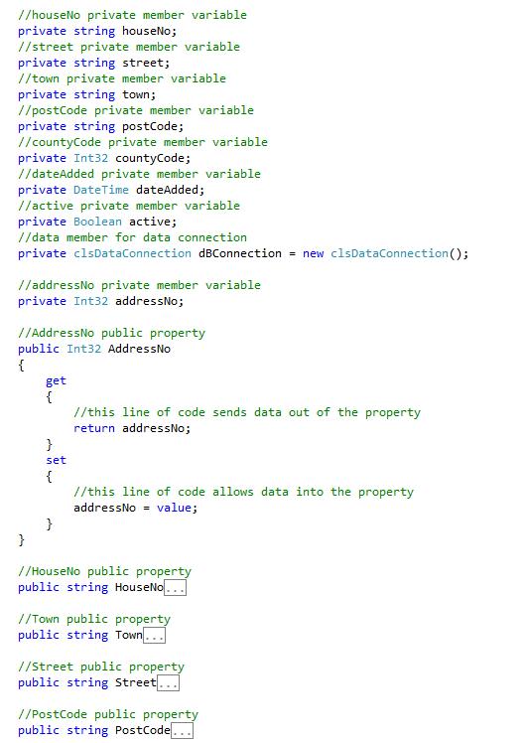
And the operations implemented as methods...
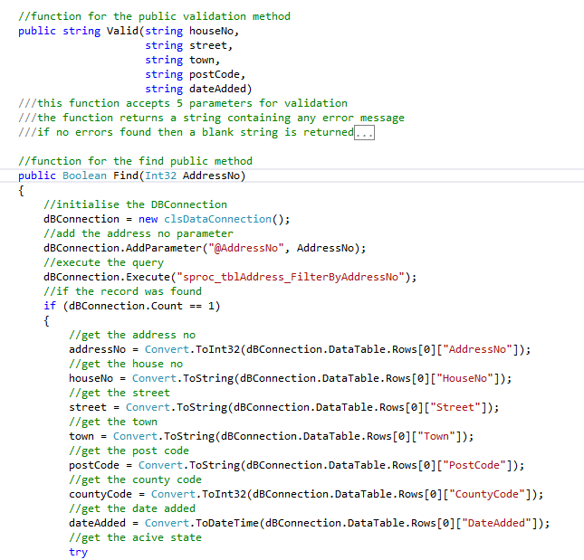
The class diagram allows us to plan out the code concentrating on what the code should do without worrying about how it will do it.

Initial class diagram
To make a start on the class diagram the event table provides us with a useful starting point.
Subject | Verb | Object | Response
Staff | Adds | Widget | Data accepted by the system
System | Validates | Widget | Reports errors if there are any
System | Edits | Widget | Old data updated with now

It is also possible to identify classes by highlighting all of the nouns in the system description…
A customer visits the web site to buy some widgets. They have the option to add themselves as a customer to the system and edit their details. Also they are able to cancel their account on-line. Upon finding out that they are not a customer they follow the sign up process entering their details and selecting a user name and password.
On the back end of the system staff have the option to manage the data for all customers (add, edit delete) and run reports on customers.
Like many of the documents at this stage we make a rough and ready stab at candidates. We may refine the list later on.
Another good place to look for ideas for classes is the Entity Relationship Diagram.
It isn’t always true but tables in the database are often mapped to classes in the middle layer.
Also look at the data dictionary too, it hold loads of possible options for attributes in your class design.

Singles and Plurals
Another thing to keep in mind at this stage is to watch out for singular and plural items.
Widget (singular) might turn out to be a different entity to Widgets (plural).
Why?
We need objects to manage individual objects, but we also need objects to manage lists of objects too (collections).
Widget and Widgets are likely to be clues to two different classes.

Authentication Example
One part of a system we are likely to have to consider is the process of authentication. We shall have a go at thinking about this and put together some candidate classes.
clsAuthenticationSystem

Attributes / Properties
Operations / Methods
What properties and methods might such a class have?
How about…
clsAuthenticationSystem
Attempts:Int32
CheckLogin(UserName:string,Password:string):Boolean
Attributes / Properties
Operations / Methods
Is it correct?
Who knows at this stage!
That isn’t the point.
Being right first time is not the object of the exercise. The object of the exercise is to make us think about how we might model the system.
After a bit more thought we might decide that there is going to be some sort of data store required for the password username data.
Let’s keep it simple and assume that it is going to be a user table in a database.
This could mean that we extend the design just a bit more to include some other classes.
clsAuthenticationSystem
Attempts:Int32
CheckLogin(UserName:string,
Password:string):Boolean
clsUser
UserNo:Int32
UserName:string
Find(UserNo)
Validate(UserDetails)
clsDataConnection
Count:Int32
DataTable:DataTable
AddParameter
(ParamName:string,
ParamValue:object):void
Execute
(SProcName:string):Int32
Is it right?
Who knows at this stage – let’s just go for it!

How do we find Associations?
An association describes how and if two classes are going to interact with each other in some way.
The first step in identifying associations is to take another look at the event table.
Subject | Verb | Object | Response
Staff | Adds | Widget | Data accepted by the system
System | Validates | Widget | Reports errors if there are any
System | Edits | Widget | Old data updated with now

From the event table we can see a clear functional link between Staff and Widget.

Multiplicity
We now need to start thinking about how the classes are related to each other.
The first factor to think about is that of multiplicity.
Multiplicity tells us how many of one class may be used by another class.
In the address book example
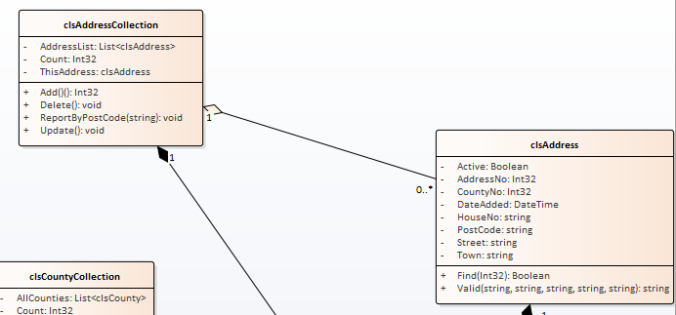
Tells us that an address collection has zero or many addresses:1 --- 0..*
In the authentication example we might go for something like this…
clsAuthenticationSystem
Attempts:Int32
CheckLogin(UserName:string,
Password:string):Boolean
clsUser
UserNo:Int32
UserName:string
Find(UserNo)
Validate(UserDetails)

clsDataConnection
Count:Int32
DataTable:DataTable
AddParameter
(ParamName:string,
ParamValue:object):void
Execute
(SProcName:string):Int32
1
1
1
1
If we have identified the multiplicity of the relationship we next need to think about the type of relationship.

Composition
Two classes are related via composition when you cannot have an instance of one class without the other class.
For example if we were placing an order in a system could we ever have an order line without an associated order?
Order
Order Line
Has
1
0..*
Attributes
Operations
Attributes
Operations

The answer is “no”.
To indicate this strong relationship between the two classes we use a solid diamond like so…
Order
Order Line
Has
1
0..*
Attributes
Operations
Attributes
Operations

Aggregation
Another relationship type between classes is an aggregation.
In this case we are asking the question “can this class exist without the associated class even though they have a relationship?”
A good example of this is customer and address…

Customer
Address
Uses
1
1..*
Attributes
Operations
Attributes
Operations

If all of the customers were to vanish from our store would addresses cease to exist?
Obviously the answer is they would not!
To indicate this looser relationship a white triangle is used like so…
Customer
Address
Uses
1
1..*
Attributes
Operations
Attributes
Operations

If we identify the composite and aggregated relationships in the diagram we get something like this…
clsAuthenticationSystem
Attempts:Int32
CheckLogin(UserName:string,
Password:string):Boolean
clsUser
UserNo:Int32
UserName:string
Find(UserNo)
Validate(UserDetails)

clsDataConnection
Count:Int32
DataTable:DataTable
AddParameter
(ParamName:string,
ParamValue:object):void
Execute
(SProcName:string):Int32
1
0..1
1
1

Collection Classes
As we draw up our class diagrams collection classes may be assumed to be required at some point.
This is why it is important to think about the difference between Widget (singular) and Widgets (plural).
A collection class is a class that specialises in the management of a number of sub class items.
For example, in this diagram...
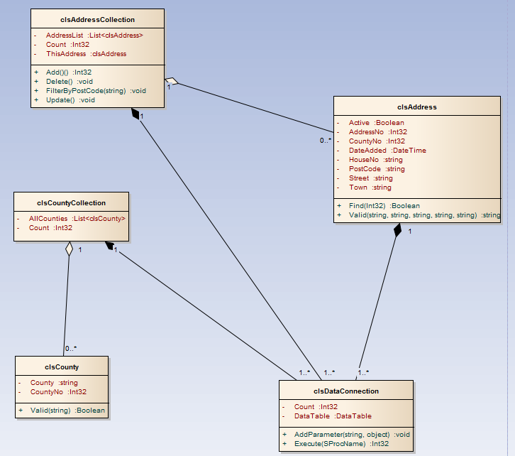
clsAddressCollection is the collection class for clsAddress
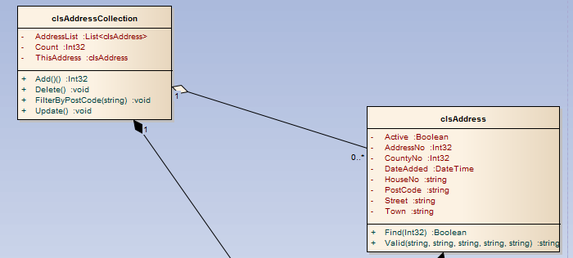
The collection class typically offers a set of methods for add, edit delete etc.

What is the Difference between a Class and an Entity?
One final thing! It really doesn’t help much when we have two documentation standards that look so similar.
The class diagram…
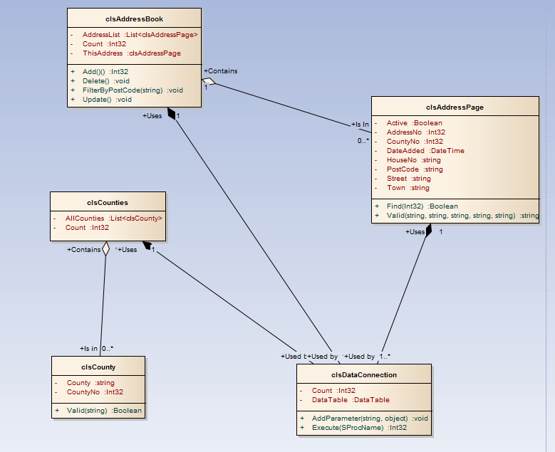
The ER Diagram…
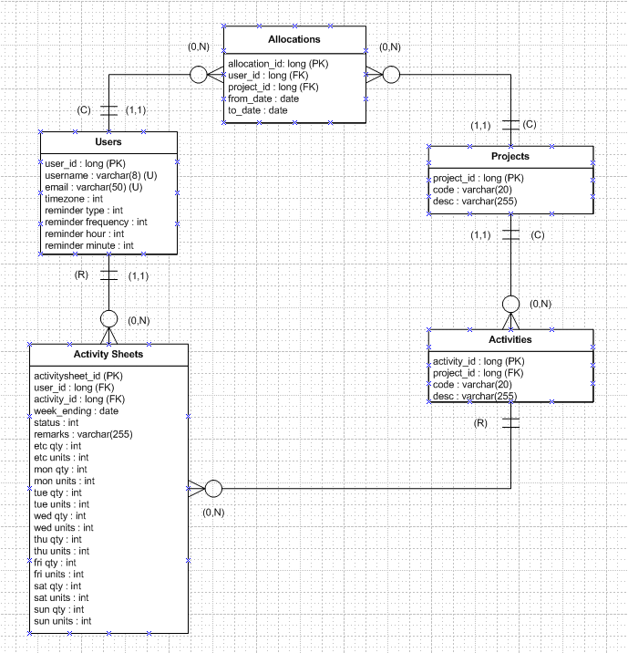
The rectangular boxes are inevitably going to look pretty similar until the subtleties are fully appreciated.
So what are the differences?

Classes do not persist
Classes are ultimately implemented as objects.
Objects exist in RAM for the duration of the function or program where they have scope. When the function or program ends the object ceases to exist.
Entities are ultimately implemented as tables.
Tables exist in the database persist and do not vanish once the program/function has completed.

Classes have Functionality Entities Don’t
When we draw up a class in EA we will give it attributes and operations.
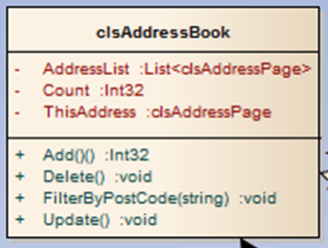
When an object is created using the class these become its methods and properties.
For example…

clsAddressBook MyAddressBook = new clsAddressBook();
MyAddressBook.FilterByPostCode(“LE1”);

The methods implement the functionality for that object.
In the case of entities we often don’t even bother with identifying the attributes, it’s often just a rectangle with the entity name inserted.
For example…

House

Site

The entities will ultimately by implemented as tables in the database with the attributes implemented as the columns.
The point is that the tables lack the functionality of objects. An entity will may have attributes but it won’t ever have operations that become methods.

“But really – aren’t they basically the same thing?”
At this level it may appear that way.
For example we might look at the following class and table definitions.
The table tblAddress looks something like this…
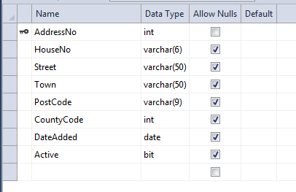
The class definition for clsAddress looks like this…
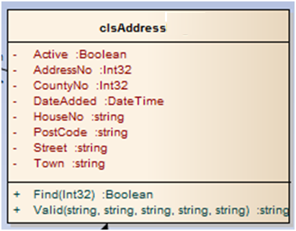
Are they not basically the same?
Well, at this level of work they probably are.
What happens is that each table ends up being “wrapped” in an object so that we may manage the rows in that table.
At this level there is a strong correlation between the structure of the class and the structure of the table.
Assuming a one to one mapping between classes and tables is often a good starting point for informing both the design of the classes and the entities.

Representing an Order
It is important to remember that this relationship does not always hold true.
A good example of this might be a class to model an order.
The order may take the following format…
Customer Name
Delivery Address
Post Code
Order line 1 Product A Unit Cost Quant Tot
Order line 1 Product B Unit Cost Quant Tot
OrderTotal
We could have a class defined in the system called clsOrder giving us access to the features of the invoice.
The data for the class would be derived from multiple tables.
For example
- Customer details would come from tblCustomer
- Product details would come from tblProduct
- There may be a stock check facility making use of tblStock
- The order is stored within two tables tblOrder and tblOrderLine
Some elements of the order would never ever be stored in the system.
For example
Order line totals and the invoice total would be calculated on the fly.
When the order is stored in the system the data contained in a single object would be distributed across multiple tables.

